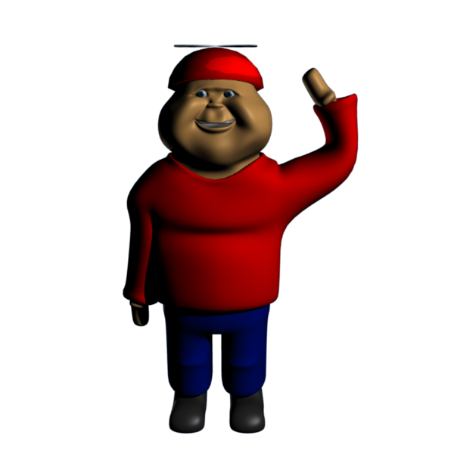

You are Fatboy, a happy little boy whose Grandpa owns the world’s greatest candy factory. But one day while making a new experimental candy something went horribly wrong and now the candies are out to eat people. Led by the mysterious Evil Gummy they have taken over the candy factory and plan to conquer the entire world. It is up to you, Fatboy, and you’re never ending hunger for candy to stop Evil Gummy and save your grandpa’s candy Factory.

|  |  |
| --- | --- |
| **FatBoy**: The Hero of our story, Fatboy loves candy and he loves his Grandpa’s candy factory, which is why he is going to do everything in his power to save it, even if it means filling up on chocolate before supper. | FatBoy.png |
| **Grandpa:** Owner of the candy factory and creator of the new evil candy that is about to conquer the whole world. His only hope for rescue is his grandson’s incredible appetite for candy. | Grampa.png |
| **Evil Gummy:** The mysterious candy mastermind who brought all the new evil candies together with a plot to take over the world. | Question_mark_alternate.png |
| **Enemies**  Candy Corns: This one time enjoyable candy snack is out for revenge. Watch out as they try to take a bite out of Fatboy (Amazingly with no mouths!)  Gums: Though complacent compared to the other candies, these gums can greatly aid FatBoy in his quest (see Controls).  Chocolate Bars: The most sinister of the bunch, this chocolate bars plan to make s’mores out of Fatboy and his grandpa. | candycorn.png  gum.pngchocolate.png |